FOR IMMEDIATE RELEASE

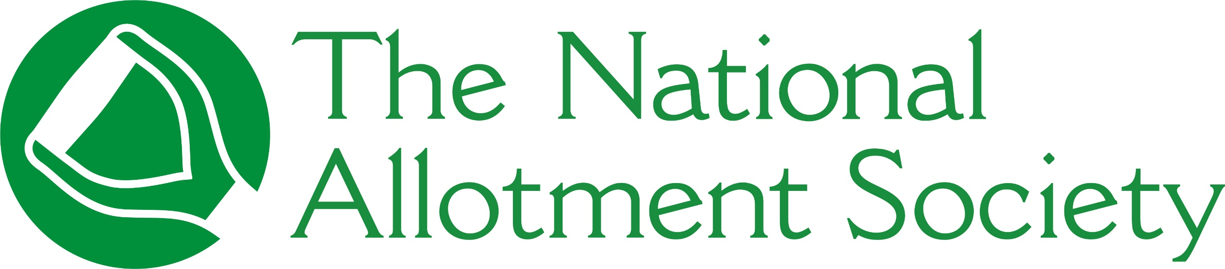

PRESS RELEASE

Monday 10th August, 2026

National Allotment Society launches National Allotments Week with call to protect allotments

The National Allotment Society (NAS), the UK’s leading representative body for allotment holders, is launching National Allotments Week 2026 (NAW) with a call for plots to be recognised, protected and properly supported.
Taking place from 10–16 August, this year’s theme, ‘Grow to Learn – Lifelong lessons from the allotment’, will shine a light on allotments as living classrooms: spaces where people of all ages can gain practical growing skills, build confidence, support their mental and physical wellbeing, and form lasting connections with nature and their local community.
As pressure on land continues and demand for plots remains high in many areas, the Society is calling for allotments to be recognised, protected and properly supported as essential community assets.

Sonia Gallagher, National Secretary and General Manager at the National Allotment Society, says that the right to grow is about giving people the opportunity to produce fresh food and take part in shared green spaces that strengthen communities. She said: “Allotments have always been places of growth in every sense of the word. They help people grow food, but they also help people grow in confidence, resilience, knowledge and friendship.

“National Allotments Week is an opportunity to celebrate the people and communities who make allotments so special, while reminding decision-makers that access to land for growing must be protected for future generations.”

Throughout NAW, plots across the country will be marking the week in their own way, from open days to photo competitions and community events, all sharing the joy and benefits of growing.
Today, Monday 10th August, the Society launches a new short film that explores the vital role allotments play in preserving traditional skills, strengthening communities, and protecting the environment. Available to view on YouTube, it shares stories, reflections and resources that demonstrate how plots support healthier lifestyles, food security, environmental awareness, intergenerational learning and social connection.

During NAW, NAS will also be announcing the winners of its national quote competition, sharing selected entries across the Society’s social media platforms. The competition gave growers the chance to share the practical, personal, humorous or inspirational lessons learned on their plots.

The winner of the Society’s Youth Allotment Ambassador Competition, which invited young growers to showcase their passion for allotments, gardening and the skills learned through growing, will also be revealed.

National Allotments Week has been celebrating the value of allotments and gardens since 2002, highlighting not only their role in growing fresh food, but also their wider contribution to healthier lifestyles, improved mental wellbeing, and stronger, more connected communities. #

To watch NAS’ new short film, visit https://youtu.be/vMKEwsk77B8

For more information about National Allotments Week 2026, visit https://thenas.org.uk/national-allotments-week

[ENDS]

Please direct any press enquiries to Emma Speirs on 01536 682800 or email emma.speirs@ballyhoo-pr.co.uk

NOTES TO EDITORS

The National Allotment Society has launched this year’s National Allotments Week under the ‘Grow to Learn’ theme

About the National Allotment Society
With over 132,000 members, The National Allotment Society (NAS) is the leading representative body for UK allotment holders. Its mission is to protect, promote and preserve allotments for future generations.

NAS works with allotment sites, associations, councils and individual plot holders to provide advice and guidance on a range of issues including site management, environmental concerns, tenancy agreements and fundraising.

For more information, go to https://thenas.org.uk/ or follow NAS on Facebook and Instagram

